**Experiment 07: Over-ride control**

**Name: Shaunak Deshpande**

**Div.: TY-IC-C**

**Roll. No.: 39**

**GR no.: 11911180**

**Batch.: 2**

**Class : TY B.Tech Instrumentation & Control**

**Course Name : Building & Process Automation**

In this override control , the AO block is used to change the process input. The impact of a change in the process input is reflected in measurements of the process output accessed by AI2 and AI1.

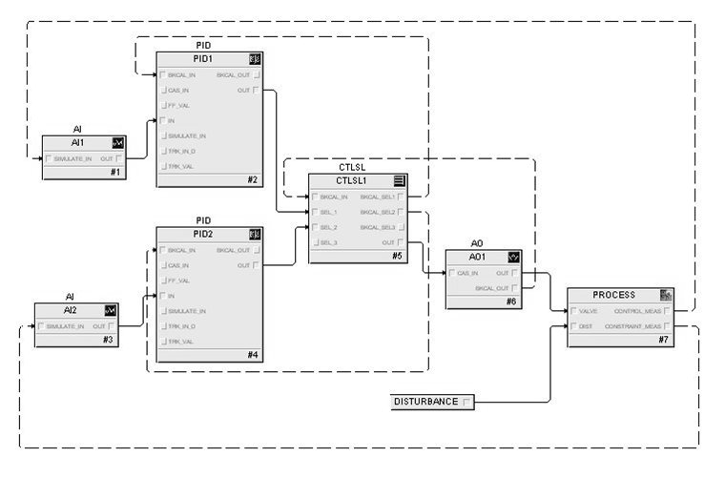

**Steps:**

Step 1. In the Override Control workspace, place the two PIDs in Auto and observe the response when both setpoints are set to 50.

Step 2. Change the setpoint of PID1 to 60 and observe the response of PID2. Change the setpoint of PID1 to 45 and observe the response.

Step 3. Change the disturbance input to 30 and observe the response of the override loop and the process response.

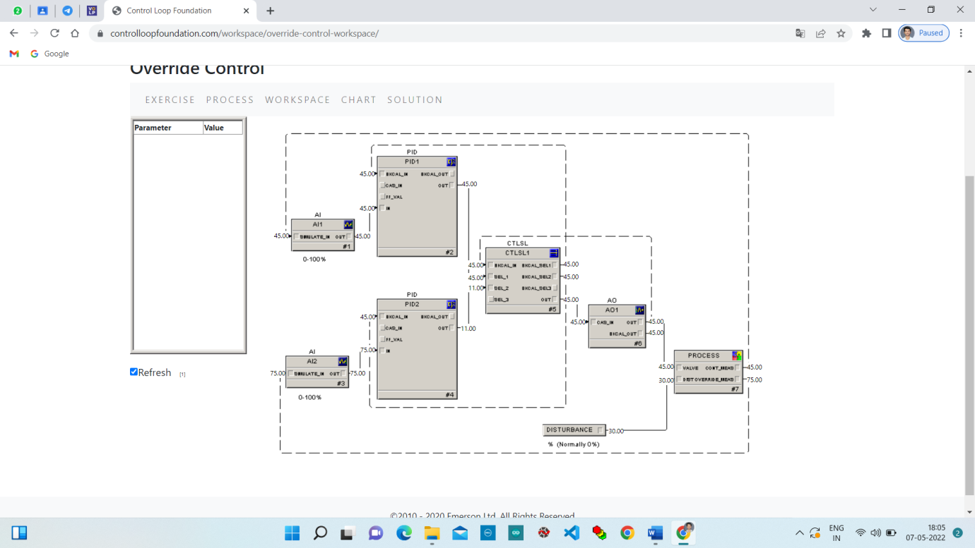

**Step 1.** In the Override Control workspace, place the two PIDs in Auto and observe the response when both setpoints are set to 50.

Change the Setpoint of PID1 from 45 to 50.

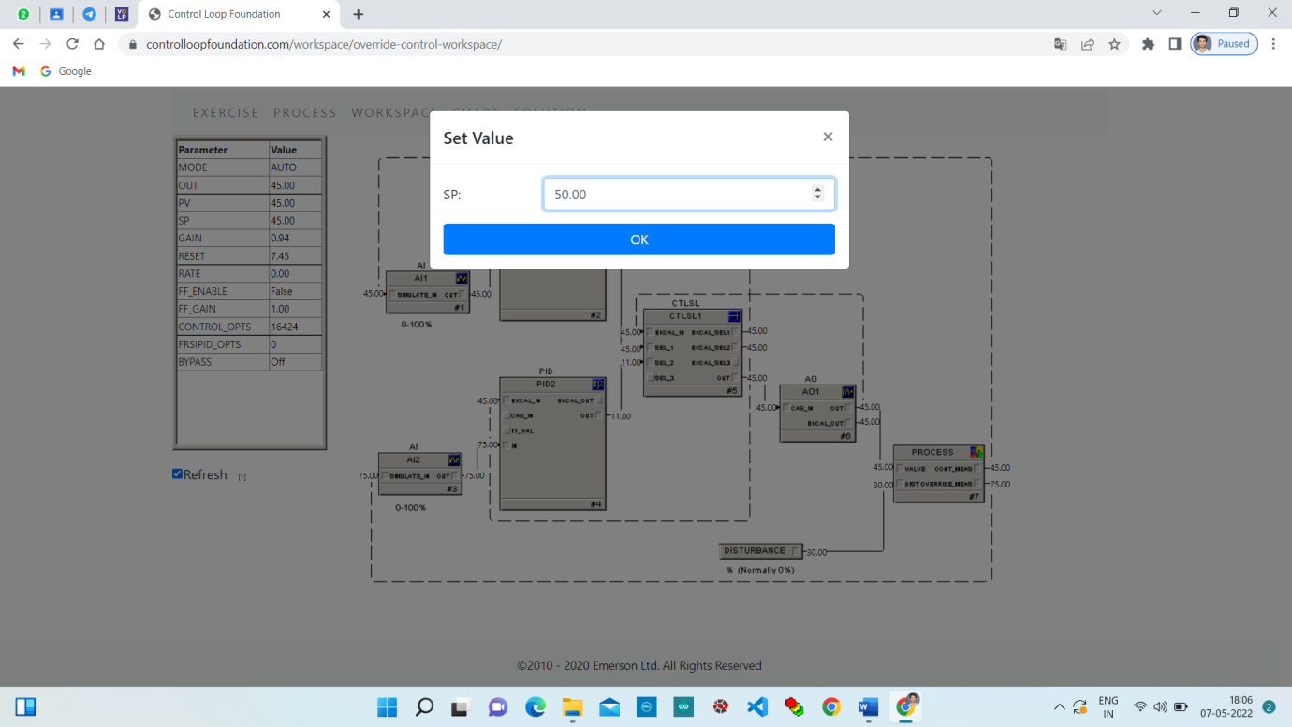

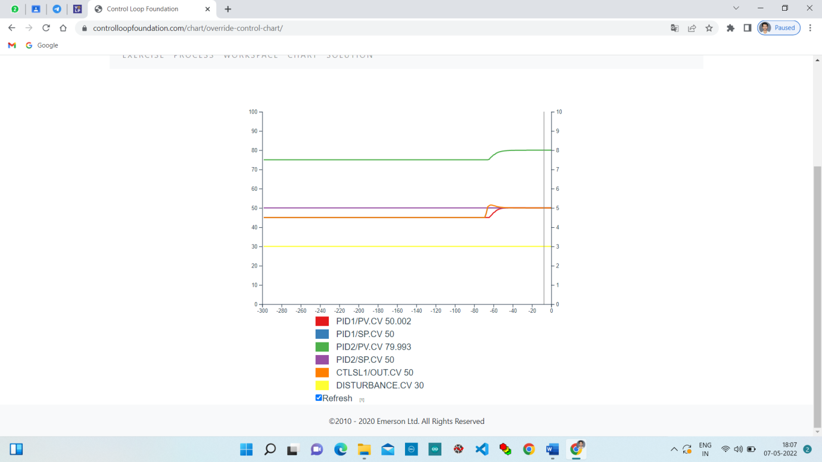

**Step 2.** Change the setpoint of PID1 to 60 and observe the response of PID2. Change the setpoint of PID1 to 45 and observe the response.

Change the Setpoint of PID1 from 50 to 60.

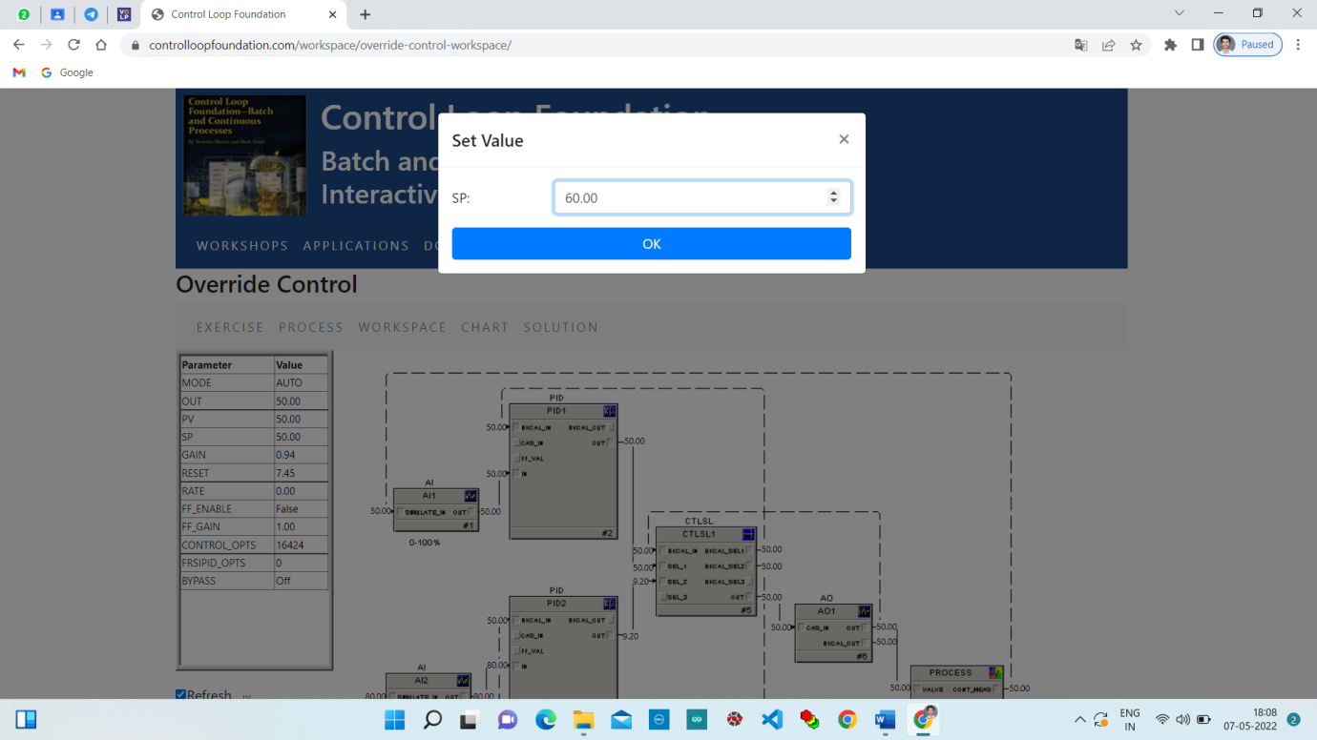

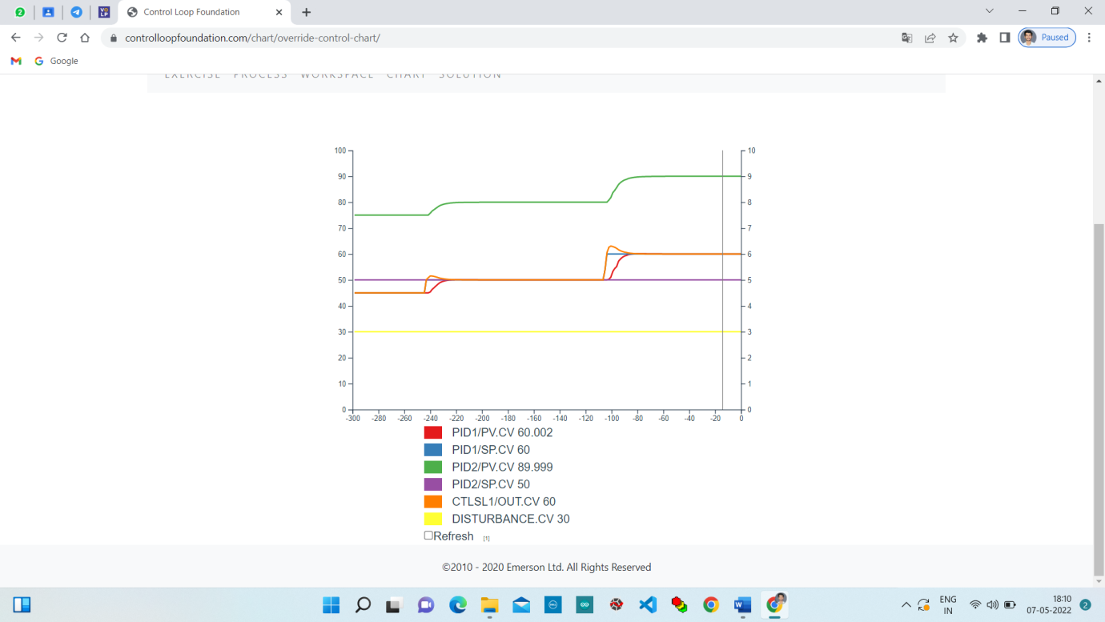

Change the Setpoint of PID1 from 60 to 45.

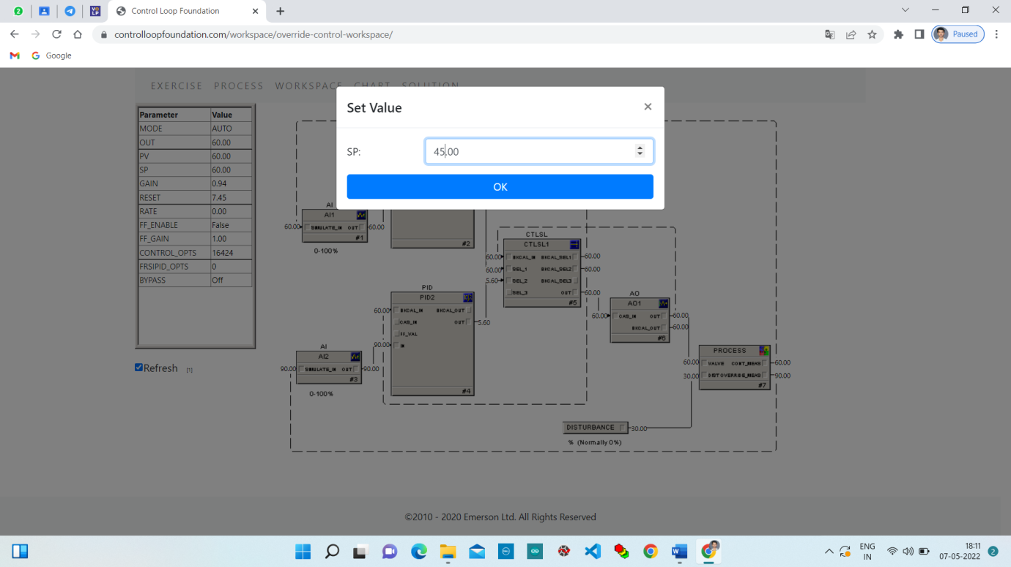

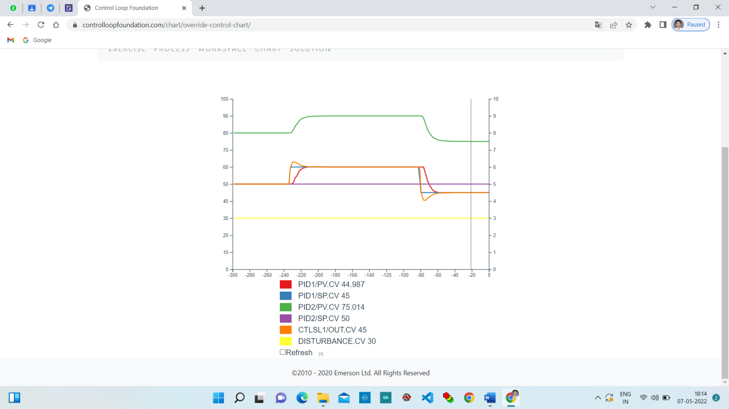

**Step 3.** Change the disturbance input to 30 and observe the response of the override loop and the process response.

Change Disturbance to 30.

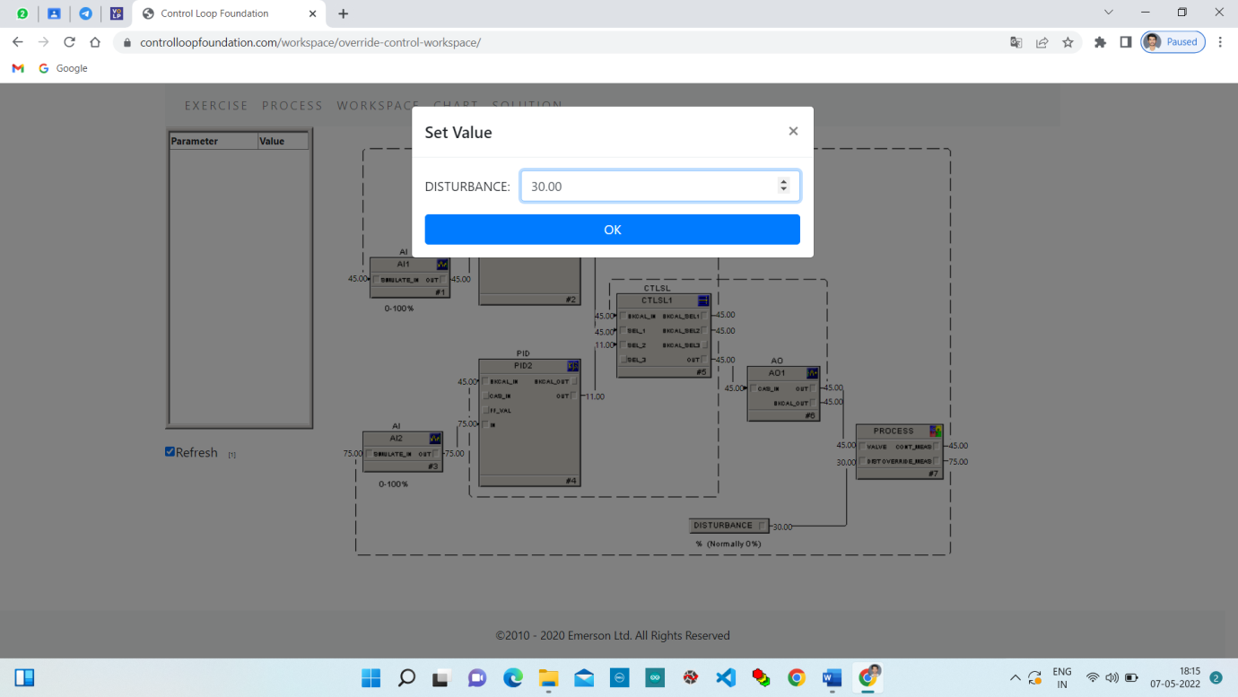

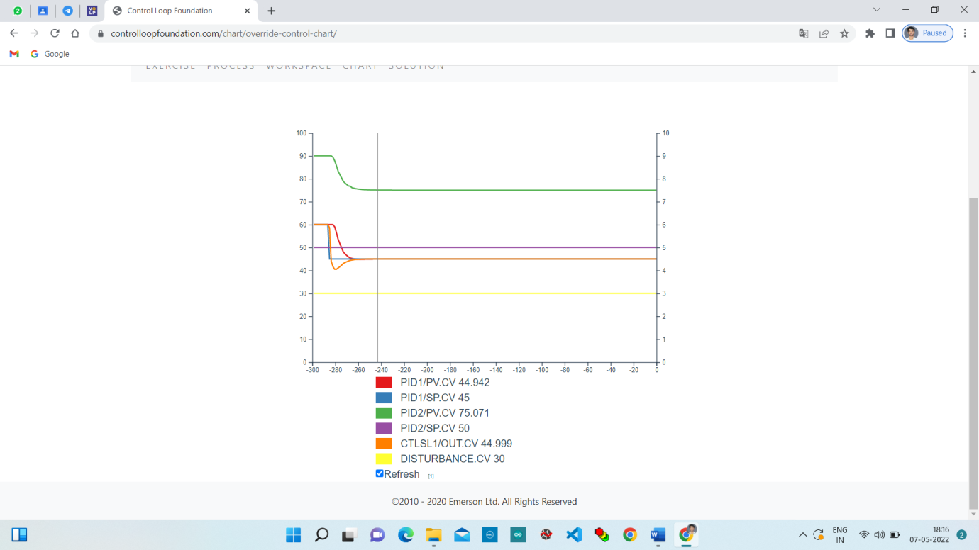

**Conclusion:**

In this lab we studied about override control and performed it on controlloop foundation and observed the responses.